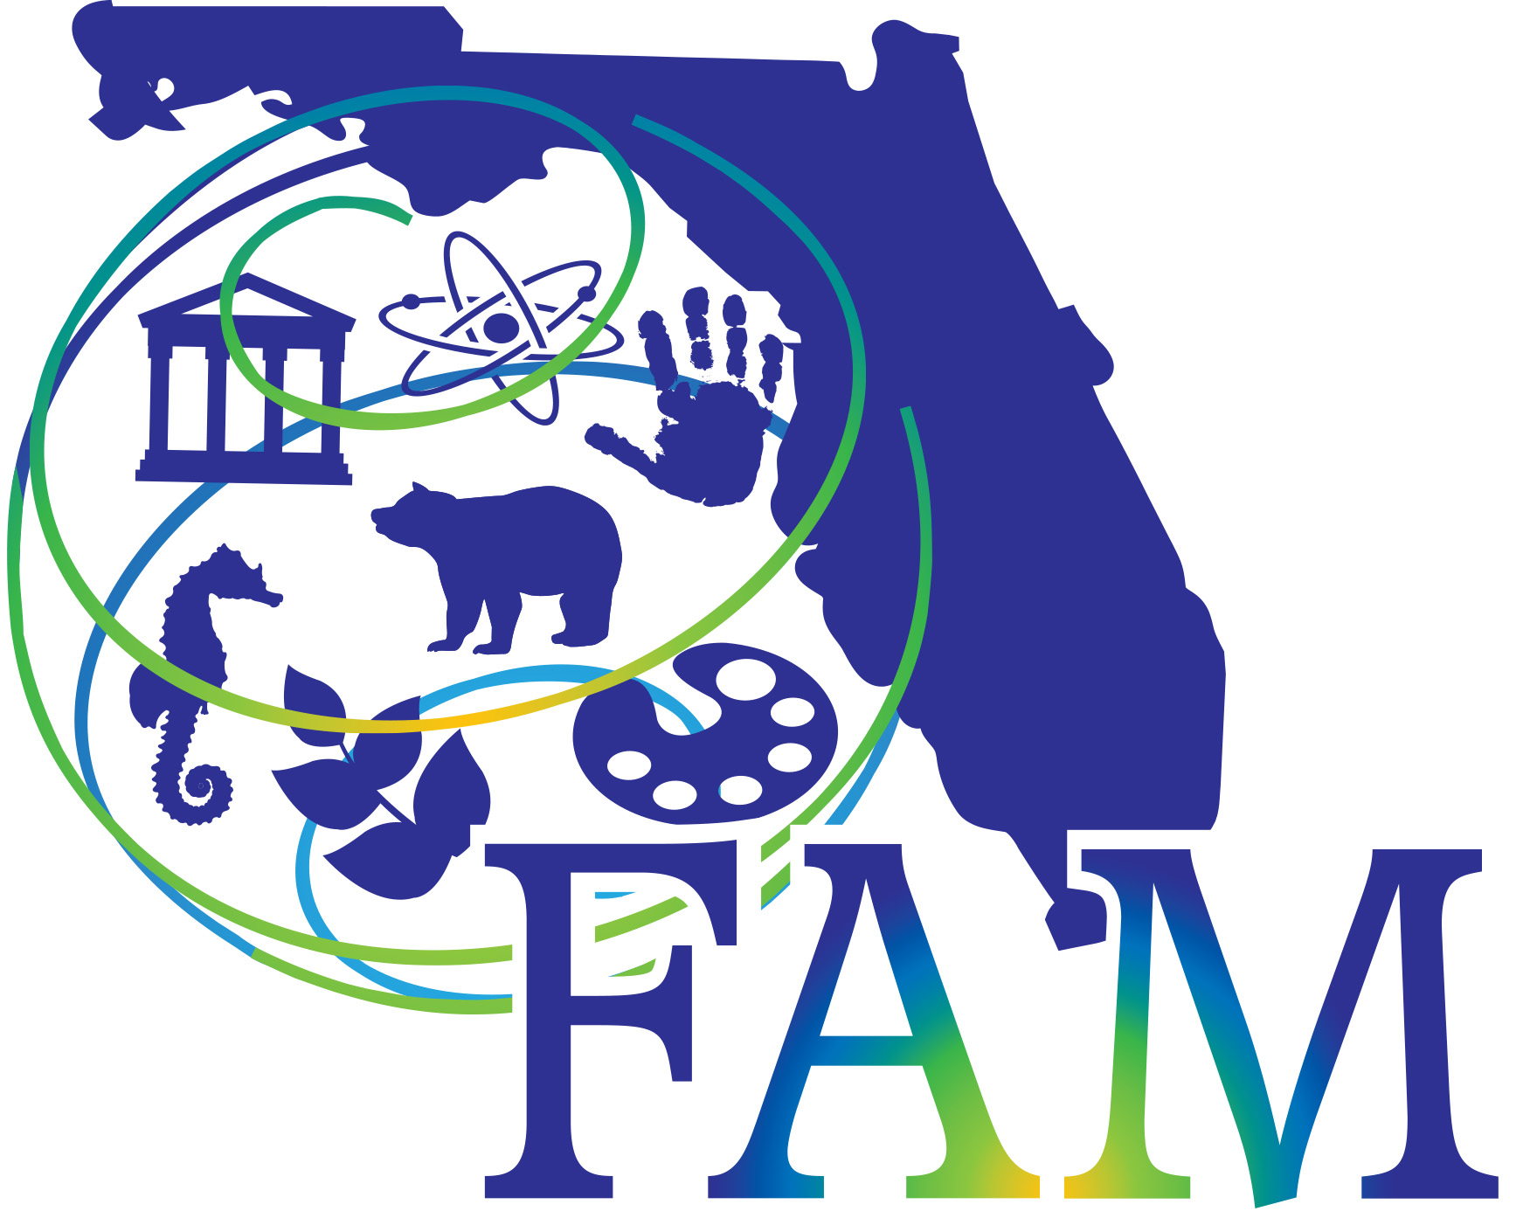
Florida Association of Museums
Emergency Planning Resources

National Resources
- Federal Emergency Management Agency (FEMA)
  - Heritage Emergency National Task Force: https://culturalrescue.si.edu/hentf/
  - HENTF fact sheets – https://www.fema.gov/media-library/assets/documents/113297
  - Integrating Historic Property and Cultural Resource Considerations into Hazard Mitigation Planning http://www.fema.gov/pdf/fima/386-6_Phase_4.pdf
  - National Response Framework - https://www.fema.gov/media-library/assets/documents/117791
  - National Disaster Recovery Framework - https://www.fema.gov/media-library/assets/documents/117794
  - Public Assistance Program and Policy Guide - https://www.fema.gov/media-library/assets/documents/111781
- NOAA Extreme Weather Information App includes national, state and local contact information as well as radio stations -- https://apps.apple.com/us/app/newis-noaa-extreme-weather-information/id669225819
- Center for Disease Control, Workplace Safety & Health Topics for Storm/Flood and Hurricane Response. http://www.cdc.gov/niosh/topics/emres/flood.html
- National Park Service Risk Assessment Worksheet http://www.nps.gov/museum/publications/MHI/Fillable_Risk_Assessment_Worksheet.pdf
State Resources
- Florida Association of Museums’ Self-Paced Program on Developing an Institution-wide Emergency Plan – The program includes webinars, samples and resources and has been divided into modules which can either be completed in order, or as needed. http://www.flamuseums.org/professional-development/florida-connecting-to-collections-program/emergency-plans/
- Florida Division of Emergency Management includes many important resources for a variety of conditions-- https://www.floridadisaster.org
  - Florida Public Assistance Program - https://floridapa.org
Local Resources
- Alliance for Response
  - Sarasota Manatee: https://www.culturalheritage.org/resources/emergencies/alliance-for-response-home/networks/sarasota
  - South Florida: http://www.heritageemergency.org/initiatives/alliance-for-response/networks/miami/
- Florida Division of Emergency Management, County Emergency Management Listing -- https://www.floridadisaster.org/counties/
Other Helpful Resources
- Building an Emergency Plan: A Guide for Museums and Other Cultural Institutions by Valerie Dorge and Sharon L. Jones (Los Angeles: J. Paul Getty Trust, 1999). http://www.getty.edu/conservation/publications_resources/pdf_publications/pdf/emergency_plan.pdf
- American Association for State and Local History (AASLH), An Ounce of Prevention – Worth MORE than a Pound (security system) http://www.connectingtocollections.org/wp-content/uploads/2012/04/Technical-Leaflet-253.pdf
- Northeast Document Conservation Center, Preservation Leaflets, Considerations for Prioritizing https://www.nedcc.org/free-resources/preservation-leaflets/1.-planning-and-prioritizing/1.4-considerations-for-prioritizing
- Minnesota Historical Society
  - Disaster Response and Recovery Resources - http://www.mnhs.org/preserve/conservation/floodresponse.php
  - Emergency Salvage Procedures for Wet Items - http://www.mnhs.org/preserve/conservation/emergency.php
- Training Texas Museums – Salvage Demonstrations
  - Metals and glass - https://www.youtube.com/watch?v=PwpiKpip8mg
  - Wet books and paper - https://www.youtube.com/watch?v=o8mp5jeaiY8
  - Wet textiles - https://www.youtube.com/watch?v=bbv8ZnCKso0&t=23s
- American Institute for Conservation - Field Guide to emergency response videos - https://www.culturalheritage.org/resources/emergencies/disaster-response-recovery/fieldguide#.Wa6sWciGO70
- NEDCC- Emergency Salvage of Wet Books and Records - https://www.nedcc.org/free-resources/preservation-leaflets/3.-emergency-management/3.6-emergency-salvage-of-wet-books-and-records
- Association of Moving Image Archives, Disaster recovery for films - https://amia.typepad.com/home_movie_recovery/

